**50VISVESVARAYA TECHNOLOGICAL UNIVERSITY**

**“JnanaSangama”, Belgaum -590014, Karnataka.**



**LAB REPORT**

**on**

Analysis and Design of Algorithms

***Submitted by***

**AVANI KAMATH(1BM21CS036)**

***in partial fulfillment for the award of the degree of***

**BACHELOR OF ENGINEERING**

***in***

**COMPUTER SCIENCE AND ENGINEERING**



**B.M.S. COLLEGE OF ENGINEERING**

**(Autonomous Institution under VTU)**

**BENGALURU-560019**

**June-2023 to September-2023**

**B. M. S. College of Engineering,**

**Bull Temple Road, Bangalore 560019**

(Affiliated To Visvesvaraya Technological University, Belgaum)

**Department of Computer Science and Engineering**



**CERTIFICATE**

This is to certify that the Lab work entitled “**Analysis and Design of Algorithms**” carried out by **AVANI KAMATH(1BM21CS036),** who is bonafide student of **B.M.S. College of Engineering.** It is in partial fulfillment for the award of **Bachelor of Engineering in Computer Science and Engineering** of the Visvesvaraya Technological University, Belgaum during the academic semester June-2023 to September-2023. The Lab report has been approved as it satisfies the academic requirements in respect of a **Analysis and Design of Algorithms (22CS4PCADA)** work prescribed for the said degree.

Name of the Lab-In charge:

Dr.Rajeshwari BS Dr. Jyothi Nayak

Designation Professor and Head

Assistant Professor Department of CSE

Department of CSE BMSCE, Bengaluru

BMSCE, Bengaluru

**Index Sheet**

|  |  |  |
| --- | --- | --- |
| **Lab Program No.** | **Program Details** | **Page No.** |
| 1 | Write program to do the following:   1. Print all the nodes reachable from a given starting node in a digraph using BFS method. 2. Check whether a given graph is connected or not using DFS method. | 5 |
| 2 | Write program to obtain the Topological ordering of vertices in a given digraph. | 10 |
| 3 | Implement Johnson Trotter algorithm to generate permutations. | 13 |
| 4 | Sort a given set of N integer elements using Merge Sort technique and compute its time taken. Run the program for different values of N and record the time taken to sort. | 17 |
| 5 | Sort a given set of N integer elements using Quick Sort technique and compute its time taken. | 20 |
| 6 | Sort a given set of N integer elements using Heap Sort technique and compute its time taken. | 23 |
| 7 | Implement 0/1 Knapsack problem using dynamic programming. | 27 |
| 8  9 | Implement All Pair Shortest paths problem using Floyd’s algorithm. | 32 |
| Find Minimum Cost Spanning Tree of a given undirected graph using Prim’s and Kruskal’s algorithm. | 35 |
| 10 | From a given vertex in a weighted connected graph, find shortest paths to other vertices using Dijkstra’s algorithm. | 43 |

|  |  |  |
| --- | --- | --- |
| 11 | Implement “N-Queens Problem” using Backtracking. | 47 |

**Course Outcome**

|  |  |
| --- | --- |
| CO1 | Analyze time complexity of Recursive and Non-recursive algorithms using asymptotic notations. |
| CO2 | Apply various design techniques for the given problem. |
| CO3 | Apply the knowledge of complexity classes P, NP, and NP-Complete and prove certain  problems are NP-Complete |
| CO4 | Design efficient algorithms and conduct practical experiments to solve problems. |

# 1(a).Write program to print all the nodes reachable from a given starting node in a digraph using BFS method.

**#include<stdio.h> #include<stdlib.h>**

**int a[10][20], q[10], visited[10], n, i, j, f = 0, r = -1;**

**void bfs(int k) {**

**for(i = 0; i < n; i++){**

**if(a[k][i] && visited[i]==0){ q[++r] = i;**

**}**

**}**

**if(f <= r){ visited[q[f]] = 1;**

**bfs(q[f++]);**

**}**

**}**

**int main() { int v;**

**printf("\nEnter the number of vertices:"); scanf("%d", &n);**

**for(i=1; i <= n; i++) {**

**q[i] = 0;**

**visited[i] = 0;**

**}**

**printf("\nEnter graph data in matrix form:\n"); for(i=0; i<n; i++) {**

**for(j=0;j<n;j++) { scanf("%d", &a[i][j]);**

**}**

**}**

**printf("\nEnter the starting vertex:"); scanf("%d", &v);**

**bfs(v);**

**printf("\nThe node which are reachable are:\n");**

**for(i=0; i < n; i++) { if(visited[i])**

**printf("%d\t", i); else {**

**printf("\nBfs is not possible. Not all nodes are reachable!\n"); break;**

**}**

**}**

**return 0;**

**}**

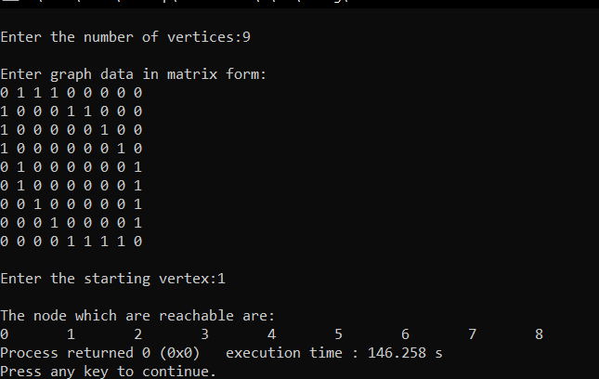**OUTPUT CASE1:**

**CASE 2:**

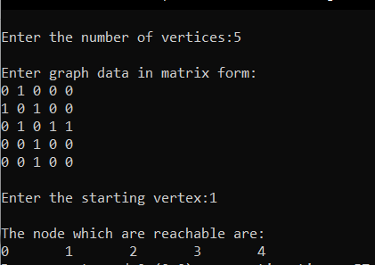

# 1(b).Write program to do the following check whether a given graph is connected or not using DFS method.

#include<stdio.h>

int graph[20][20], vis[10]; void DFS(int i,int n){

int j; printf("Visited:%d\n",i); vis[i]=1; for(j=0;j<n;j++){

if(graph[i][j]==1 && vis[j]==0){ DFS(j,n);

}

}

}

void main(){

int n,i,j,top=-1;

printf("Enter the number of vertices:\n"); scanf("%d",&n);

printf("Enter the adjacency matrix representing the graph:\n"); int vis[n],st[n];

for(int i=0;i<n;i++){ for(int j=0;j<n;j++){

scanf("%d",&graph[i][j]);

}

}

for(int i=0;i<n;i++){ vis[i]=0;

}

DFS(0,n);

}

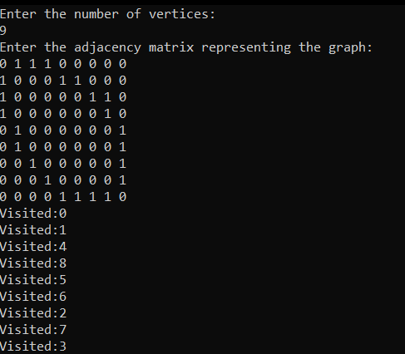OUTPUT CASE1:

CASE2:

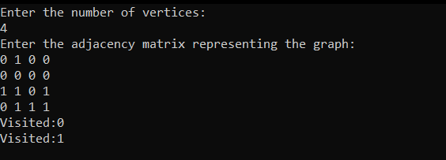

# Write program to obtain the Topological ordering of vertices in a given digraph

#include<stdio.h> #include<stdlib.h>

int visited[50],graph[10][10],n,stack[10],top=-1; void topological_sort(int node){

visited[node]=1;

for(int j=0;j<n;j++){

if(graph[node][j]==1 && visited[j]!=1){ topological_sort(j);

}

}

stack[++top]=node;

}

int main(){

printf("Enter Number of nodes\n"); scanf("%d",&n);

printf("Enter the matrix\n"); for(int i=0;i<n;i++){

for(int j=0;j<n;j++){ int key; scanf("%d",&key);

graph[i][j]=key;

}

}for(int i=0;i<n;i++){ topological_sort(i);

}

printf("\nTOPOLOGICAL SORT\n"); while(top!=-1){

printf("%d ",stack[top--]);

}

return 0;

}

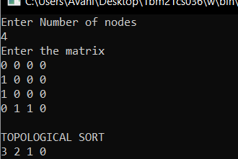OUTPUT CASE1:

CASE 2:

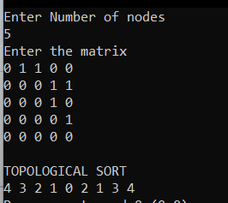

# Implement Johnson Trotter algorithm to generate permutations.

#include <stdio.h> #include <conio.h>

int NN, i, count=0; int p[100], pi[100]; int dir[100];

void PrintPerm()

{

int i;

for (i=1; i <= NN; ++i) printf( "%d", p[i] ); printf("\n");

}

void Move( int x, int d )

{

int z;

z = p[pi[x]+d];

p[pi[x]] = z;

p[pi[x]+d] = x;

pi[z] = pi[x];

pi[x] = pi[x]+d;

}

void Perm ( int n )

{

int i;

if (n > NN) PrintPerm();

else

{

Perm( n+1 );

for (i=1; i<=n-1; ++i)

{

Move( n, dir[n] ); Perm( n+1 );

}

dir[n] = -dir[n];

}

}

void main ()

{

printf( "Enter n: " );

scanf( "%d", &NN );

printf( "\n" );

for (i=1; i<=NN; ++i)

{

dir[i] = -1; p[i] = i; pi[i] = i;

}

Perm ( 1 ); printf( "\n" );

}

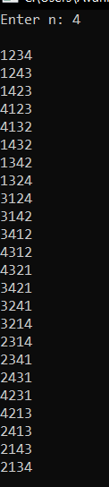OUTPUT CASE1:

CASE2:

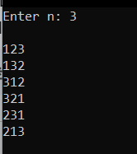

# Sort a given set of N integer elements using Merge Sort technique and compute its time taken. Run the program for different values of N and record the time taken to sort.

#include <stdio.h> #include <stdlib.h>

int res[10], n;

void SortedMerge(int arr[], int l, int m, int h) { int i=l, j=m+1, k=0;

while (i<=m && j<=h){ if (arr[i]<arr[j]){

res[k]=arr[i]; i++;

}

else{

res[k]=arr[j]; j++;

} k++;

}

while (i<=m){ res[k++]=arr[i++];

}

while (j<=h){ res[k]=arr[j]; k++;

j++;

}

for (int i=0; i<(h-l)+1; i++) { arr[l+i]=res[i];

}

}

void Merge(int arr[], int l, int h){ if (l<h){

int m = (l+h)/2; Merge(arr, l, m); Merge(arr, m+1, h); SortedMerge(arr, l, m , h);

}

}

int main(){ int a[10],i;

printf ("Enter size of array:\n"); scanf("%d",&n);

printf ("Enter elements:\n"); for (i=0; i<n; i++){

scanf("%d",&a[i]);

}

Merge(a,0,n-1);

for (i=0; i<n; i++){ printf ("%d ",a[i]);

}

return 0;

}

OUTPUT CASE1:

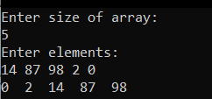

CASE2:

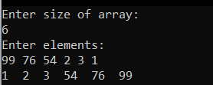

# Sort a given set of N integer elements using Quick Sort technique and compute its time taken.

#include <stdio.h>

void swap(int* a, int* b) { int temp = *a;

*a = *b;

*b = temp;

}

int partition(int arr[], int low, int high) { int i=low, j=high+1;

int pivot=arr[low];

while (i<j){

while (pivot >= arr[i]) i++; while (pivot < arr[j]) j--;

if (i<j) swap(&arr[i], &arr[j]);

}

swap (&arr[low], &arr[j]); return j;

}

void quickSort(int arr[], int low, int high) { if (low < high) {

int j = partition(arr, low, high);

quickSort(arr, low, j-1); quickSort(arr, j+1, high);

}

}

int main() {

int arr[10], n, i;

printf("Enter no. of elemetns:\n"); scanf ("%d", &n);

printf ("Enter elements:\n"); for (i=0; i<n; i++){

scanf ("%d",&arr[i]);

}

quickSort(arr, 0, n-1);

printf("Sorted array: "); for (i=0; i<n; i++){

printf ("%d ", arr[i]);

}

return 0;

}

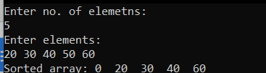OUTPUT CASE1:

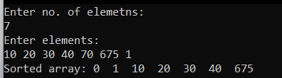CASE2:

# Sort a given set of N integer elements using Heap Sort technique and compute its time taken.

#include <stdio.h> #include <stdlib.h>

void swap (int *x, int *y){ int temp = *x;

*x = *y;

*y = temp;

}

void heapify (int arr[], int n, int i){

int largest = i, left = 2*i+1, right = 2*i+2;

if (left < n && arr[left] > arr[largest]){ largest = left;

}

if (right < n && arr[right] > arr[largest]){ largest = right;

}

if (largest != i){

swap (&arr[i], &arr[largest]); heapify (arr, n, largest);

}

}

void heapsort (int arr[], int n){ for (int i=n/2-1; i>=0; i--){

heapify (arr, n, i);

}

for (int i=n-1; i>=0; i--){

swap (&arr[0], &arr[i]); heapify (arr, i, 0);

}

}

int main (){ int n;

printf ("Enter number of elements: "); scanf ("%d", &n);

int arr[n];

printf ("Enter the elements: "); for (int i = 0; i < n; i++){

scanf ("%d", &arr[i]);

}

heapsort (arr, n);

printf ("Sorted elements: "); for (int i=0; i<n; i++){

printf ("%d ", arr[i]);

}

printf ("\n"); return 0;

}

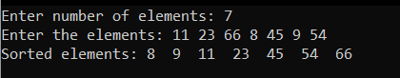OUTPUT CASE1:

CASE2:

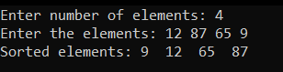

# Implement 0/1 Knapsack problem using dynamic programming.

**#include<stdio.h> #include<conio.h> void knapsack(); int max(int,int);**

**int i,j,n,m,p[10],w[10],v[10][10]; void main()**

**{**

**printf("\nenter the no. of items:\t"); scanf("%d",&n);**

**printf("\nenter the weight of the each item:\n"); for(i=1;i<=n;i++)**

**{**

**scanf("%d",&w[i]);**

**}**

**printf("\nenter the profit of each item:\n"); for(i=1;i<=n;i++)**

**{**

**scanf("%d",&p[i]);**

**}**

**printf("\nenter the knapsack's capacity:\t"); scanf("%d",&m);**

**knapsack(); getch();**

**}**

**void knapsack()**

**{**

**int x[10]; for(i=0;i<=n;i++)**

**{**

**for(j=0;j<=m;j++)**

**{**

**if(i==0||j==0)**

**{**

**v[i][j]=0;**

**}**

**else if(j-w[i]<0)**

**{**

**v[i][j]=v[i-1][j];**

**}**

**else**

**{**

**v[i][j]=max(v[i-1][j],v[i-1][j-w[i]]+p[i]);**

**}**

**}**

**}**

**printf("\nthe output is:\n"); for(i=0;i<=n;i++)**

**{**

**for(j=0;j<=m;j++)**

**{**

**printf("%d\t",v[i][j]);**

**}**

**printf("\n\n");**

**}**

**printf("\nthe optimal solution is %d",v[n][m]); printf("\nthe solution vector is:\n"); for(i=n;i>=1;i--)**

**{**

**if(v[i][m]!=v[i-1][m])**

**{**

**x[i]=1;**

**m=m-w[i];**

**}**

**else**

**{**

**x[i]=0;**

**}**

**}**

**for(i=1;i<=n;i++)**

**{**

**printf("%d\t",x[i]);**

**}**

**}**

**int max(int x,int y)**

**{**

**if(x>y)**

**{**

**return x;**

**}**

**else**

**{**

**return y;**

**}**

**}**

**OUTPUT**

CASE1:

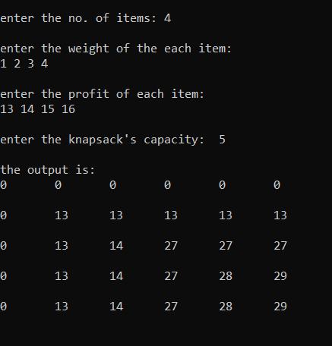

CASE 2:

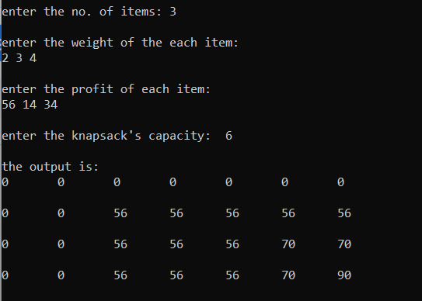

# Implement All Pair Shortest paths problem using Floyd’s algorithm.

#include <stdio.h> #include <stdlib.h> #include <limits.h>

int min (int a, int b) { return a < b ? a : b;

}

int main(){

int n, graph[10][10], i, j, k;

printf("Enter the number of vertices:\n"); scanf("%d",&n);

printf("Enter the weighs of graph in the form of an adjecency matrix:\n"); for (int i=0; i<n; i++){

for (int j=0; j<n; j++) {

scanf ("%d", &graph[i][j]);

if (i==j) graph[i][j]=0;

else if (graph[i][j]==0) graph[i][j] = INT_MAX/3;

}

}

for (k=0; k<n; k++) {

for (i=0; i<n; i++){ for (j=0; j<n; j++){

graph[i][j] = min(graph[i][j], graph[i][k]+graph[k][j]);

}

}

}

for (i=0; i<n; i++){ printf ("\n");

for (j=0; j<n; j++) {

printf ("%d ", graph[i][j]);

}

}

return 0;

}

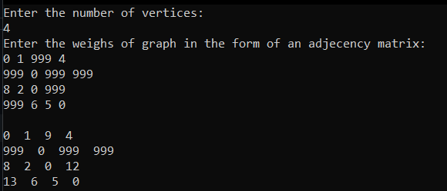OUTPUT CASE 1:

CASE 2:

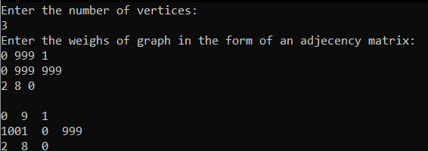

# Find Minimum Cost Spanning Tree of a given undirected graph using Prim’s and Kruskal’s algorithm.

PRIMS ALGORITHM

#include<stdio.h>

int cost[10][10],vt[10],et[10][10],vis[10],j,n; int sum=0;

int x=1; int e=0;

void prims();

int main()

{

int i;

printf("enter the number of vertices\n"); scanf("%d",&n);

printf("enter the cost adjacency matrix\n"); for(i=1;i<=n;i++)

{

for(j=1;j<=n;j++)

{

scanf("%d",&cost[i][j]);

}

vis[i]=0;

}

prims();

printf("edges of spanning tree\n"); for(i=1;i<=e;i++)

{

printf("%d,%d\t",et[i][0],et[i][1]);

}

printf("weight=%d\n",sum); return 0;

}

void prims()

{

int s,min,m,k,u,v; vt[x]=1;

vis[x]=1; for(s=1;s<n;s++)

{

j=x; min=999; while(j>0)

{

k=vt[j];

for(m=2;m<=n;m++)

{

if(vis[m]==0)

{

if(cost[k][m]<min)

{

min=cost[k][m]; u=k;

v=m;

}

}

}

j--;

}

vt[++x]=v; et[s][0]=u;

et[s][1]=v; e++;

vis[v]=1; sum=sum+min;

}

}

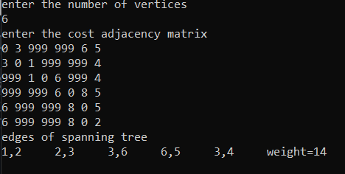OUTPUT CASE1:

CASE 2:

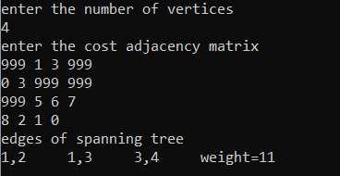

KRUSHKALS ALGORITHM

#include <stdio.h>

int find(int v, int parent[10])

{

while (parent[v] != v)

{

v = parent[v];

}

return v;

}

void union1(int i, int j, int parent[10])

{

if (i < j) parent[j] = i;

else

parent[i] = j;

}

void kruskal(int n, int a[10][10])

{

int count, k, min, sum, i, j, t[10][10], u, v, parent[10]; count = 0;

k = 0;

sum = 0;

for (i = 0; i < n; i++) parent[i] = i;

while (count != n - 1)

{

min = 999;

for (i = 0; i < n; i++)

{

for (j = 0; j < n; j++)

{

if (a[i][j] < min && a[i][j] != 0)

{

min = a[i][j]; u = i;

v = j;

}

}

}

i = find(u, parent); j = find(v, parent); if (i != j)

{

union1(i, j, parent); t[k][0] = u;

t[k][1] = v; k++;

count++;

sum = sum + a[u][v];

}

a[u][v] = a[v][u] = 999;

}

if (count == n - 1)

{

printf("spanning tree\n"); for (i = 0; i < n - 1; i++)

{

printf("%d %d\n", t[i][0], t[i][1]);

}

printf("cost of spanning tree=%d\n", sum);

}

else

printf("spanning tree does not exist\n");

}

int main()

{

int n, i, j, a[10][10];

printf("enter the number of nodes\n"); scanf("%d", &n);

printf("enter the adjacency matrix\n"); for (i = 0; i < n; i++)

{

for (j = 0; j < n; j++) scanf("%d", &a[i][j]);

}

kruskal(n, a); return 0;

}

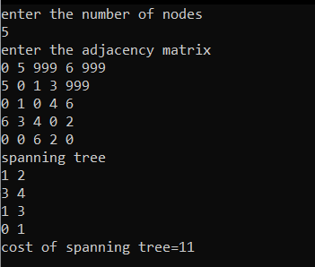OUTPUT CASE 1:

CASE 2:

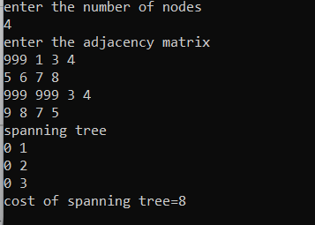

# From a given vertex in a weighted connected graph, find shortest paths to other vertices using Dijkstra’s algorithm.

#include <stdio.h> #include <conio.h>

void dijkstras();

int c[10][10], n, src;

void printPath(int parent[], int node);

void main()

{

int i, j;

printf("\nEnter the no of vertices:\t"); scanf("%d", &n);

printf("\nEnter the cost matrix:\n"); for (i = 1; i <= n; i++)

{

for (j = 1; j <= n; j++)

{

scanf("%d", &c[i][j]);

}

}

printf("\nEnter the source node:\t"); scanf("%d", &src);

dijkstras(); getch();

}

void dijkstras()

{

int vis[10], dist[10], parent[10], u, j, count, min; for (j = 1; j <= n; j++)

{

dist[j] = c[src][j]; parent[j] = src;

}

for (j = 1; j <= n; j++)

{

vis[j] = 0;

}

dist[src] = 0;

vis[src] = 1;

count = 1;

while (count != n)

{

min = 9999;

for (j = 1; j <= n; j++)

{

if (dist[j] < min && vis[j] != 1)

{

min = dist[j]; u = j;

}

}

vis[u] = 1; count++;

for (j = 1; j <= n; j++)

{

if (min + c[u][j] < dist[j] && vis[j] != 1)

{

dist[j] = min + c[u][j]; parent[j] = u;

}

}

}

printf("\nThe shortest distance is:\n"); for (j = 1; j <= n; j++)

{

printf("\n%d-->%d=%d (Path: %d", src, j, dist[j], src); printPath(parent, j);

printf(")");

}

}

void printPath(int parent[], int node)

{

if (parent[node] == src)

{

printf("->%d", node); return;

}

printPath(parent, parent[node]); printf("->%d", node);

}

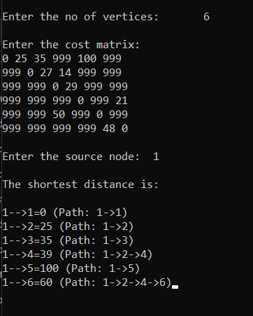OUTPUT CASE 1:

CASE 2:

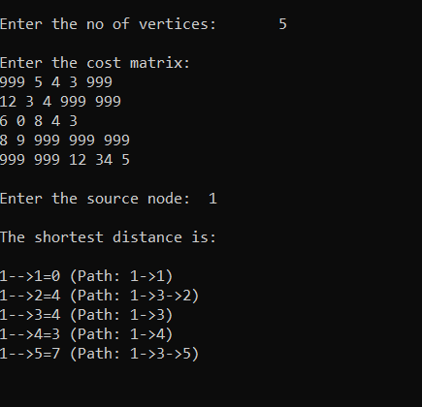

# Implement “N-Queens Problem” using Backtracking.

#include<stdio.h> #include<math.h>

int board[20],count; int main()

{

int n,i,j;

void queen(int row,int n);

printf(" - N Queens Problem Using Backtracking -"); printf("\n\nEnter number of Queens:"); scanf("%d",&n);

queen(1,n); return 0;

}

void print(int n)

{

int i,j;

printf("\n\nSolution %d:\n\n",++count);

for(i=1;i<=n;++i) printf("\t%d",i);

for(i=1;i<=n;++i)

{

printf("\n\n%d",i); for(j=1;j<=n;++j)

{

if(board[i]==j) printf("\tQ"); else

printf("\t-");

}

}

}

int place(int row,int column)

{

int i;

for(i=1;i<=row-1;++i)

{

if(board[i]==column) return 0;

else

if(abs(board[i]-column)==abs(i-row)) return 0;

}

return 1;

}

void queen(int row,int n)

{

int column; for(column=1;column<=n;++column)

{

if(place(row,column))

{

board[row]=column; if(row==n)

print(n); else

queen(row+1,n);

}

}

}

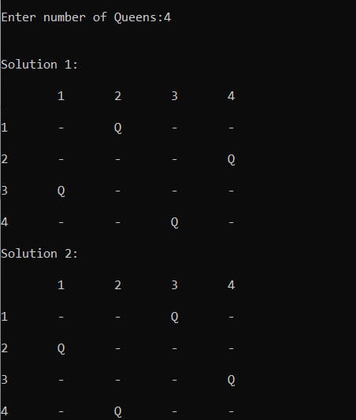OUTPUT CASE 1:

CASE 2:

